
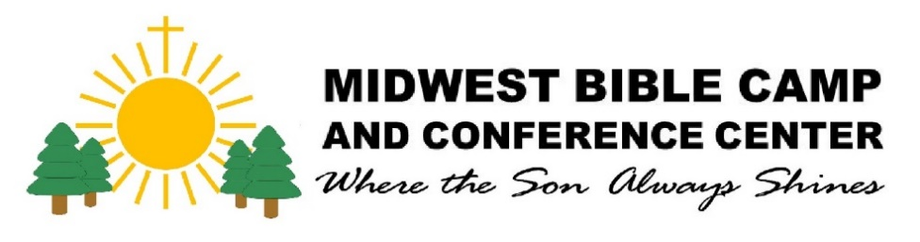
Small Rooms
2 Kings 4:10
A ministry of Midwest Bible Camp

1500 N Hwy 20 Watertown SD 57201 Phone: 886-3165

Name:________________________________________________
Date of Birth: __________________ Phone: _________________
Driver’s License or State ID: ______________________________ Email: _____________________________
Vehicle: Make ____________________ Color _______________ Plate _________________
Emergency Contact: ____________________ Cell: ____________ Relationship: ______________________
Address: _________________________________ City: ____________________ State: ____ Zip: _________ Court Services Officer: _________________________ Ph: ______________ Email: ___________________
Employer: _______________________________ Phone: ________________City: _____________________
Incidentals (curfew, meds, health concerns, food restrictions): ____________________________________
Small Rooms began in 2018 in response to those needing safe transitional housing to recover or relaunch their lives. Whether a person needs transitional housing, or is recovering from substance abuse, financial disaster, or other setbacks, we desire to provide a place of peace, unconditional love, and new beginnings. Our rooms are reserved for guests referred to us by Codington County Welfare, Codington County Drug Court and Court Services Officers, Parole Services with the South Dakota Department of Corrections, and Inter-lakes Community Action Partnership (ICAP). Guests may not have past or present charges or felony convictions for violent or sexual crimes. Requirements for a stay include an understanding of and adherence of the following conditions. Please initial after each statement to show you understand and accept it.

We will provide:
- A safe, clean room, including a bed with pillows and linens, a chair, and one set of towels. _______
- A private bathroom with a shower, stool, and sink. There will be an initial supply of paper products. _______
- Each room has a microwave and a small refrigerator. _______
- Rooms have a private heater. Most rooms have a private air conditioner. Additional heaters are not allowed. If you are not present, all heaters, AC units, and fans must be turned off. If a thermostat in your room controls the entire building (Community Room in the Lodge and F2 in Fourmore), do not change the settings without permission. _______
- There is a dresser, small rack, or hooks for hanging clothes. _______
- There will be one key for the room. Your key is not to be duplicated and is restricted for your use only. ______
- Laundry services, self-serve, donation based in our Laundry Building, between 6:00 AM and 10:00 PM _____
- Mail slots are located to the right interior entrance of the Community Room. _____
- MBC buildings and property are covered by liability insurance. Guests' personal property is not covered. Renter's insurance is encouraged. _______
- A safe and discreet environment. Guests must remain confidential about other guests. No loaning/borrowing any items or money between guests.
- WIFI is available. Network name: MWBC; Password: Mwbc2020!

Our Expectations from you:
- This room is provided only for you. No visitors in your room without prior approval.________
- There are to be no overnight visits. _______
- Conjugal visits are not allowed. _______
- Visitors on MBC property cannot be on the Sex Offender Registry or have been convicted of a violent crime, even if picking you up or dropping you off. _______
- Sex, alcohol, and illegal drugs are prohibited on our premises, including vehicles. _______
- Medical marijuana use only after presenting a valid prescription. Misuse of inhalants, rubbing alcohol, cough syrup, or any other means used as a stimulant is forbidden. _______
- The use of candles, incense, or any live flames is prohibited. _______
- Tobacco, vaping, or e-cigarettes are prohibited in the buildings. Smoking will be allowed in designated areas outside your room entry. Cigarette butts are to be discarded in the provided receptacle. _______
- Do not remove or hang anything on the walls, rearrange furniture, remove lightbulbs, or attempt repairs. ___
- No pets are allowed. _______
- You must clean your room, including dusting, vacuuming, emptying trash, and laundering your towels and linens at least once weekly. Cleaning supplies and vacuum are in the Designated Area (ask MBC staff for the current location). You are responsible for snow removal in front of your building entry. Shovels are provided. _______
- Trash may be emptied into the BLUE garbage bins on the Lodge's South side. _______
- Please ensure your outer storm door latches when entering and leaving your room. _______
- You are responsible for any damage or missing items in your room. _______
- We are not responsible for your personal belongings left behind upon ending your stay with us. Any items left will be discarded after two weeks of your departure. _______
- Guests must pay a $400.00 Security Deposit and first month rent before moving in. They are responsible for the monthly room fee of $400.00, which is due on the first of the month. ______
- Guests must use the west driveway, both personally and for arranged transportation. ________
- Storage is not allowed on site. ________

By signing this agreement, I acknowledge that I have read and understand the above rules and expectations of MBC. I also understand that if I do not abide by the rules and expectations, I may no longer be a guest at MBC.
Guest Signature ____________________________________________ Date ______________________
MBC Staff_________________________________________________ Date ______________________
You may contact our office at 605-886-3165 M-F, 8:30 am -5 pm. Please leave a message if there is no answer. If your need is urgent, please call Hank Roso directly at 815-549-0825. You may also visit the office during business hours.

