

Camp Schedule 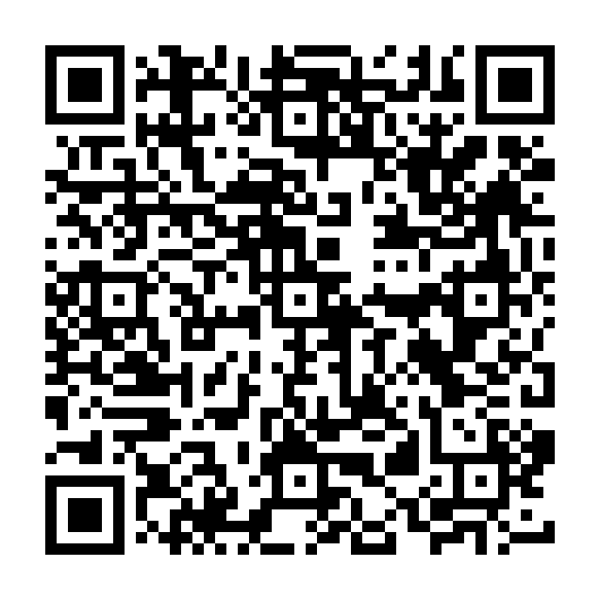

Learning about God and His love
for us. Music, laughter and
closeness happens naturally as we present biblical truths like honesty, respect, integrity, kindness and real joy…exactly what you’d expect from a Bible Camp experience.

Day 1
3:00 – 5:00 PM Arrival & Pizza
6:00 PM Chapel
8:00 PM Fire Time

Day 2, 3, & 4
7:00 AM Rising Bell
7:30 AM Devotions
8:00 AM Breakfast
9:00 AM Chapel
10:45 AM Bible Studies *
12:00 PM Lunch
1:00 PM Activities
5:00 PM Supper
6:00 PM Chapel
8:00 PM Fire Time
9:00 PM Dorm Devotions
10:30 PM Lights Out

*Youth and Adult Bible Studies are available

Day Camp: Drop your child(ren) off before or after breakfast and pick them up anytime through the evening; right up until the close of canteen at 8 PM

Final Day Family Fun!
Dads and moms, grandparents, family, and friends, join us from 5-6 PM for FREE COOKOUT SUPPER and stay to join our kids for a fantastic closing evening service at 6PM. Stay for FREE ice cream and popcorn following the service! Come join the fun!

Register Early
Ministry and Worship
All Meals Included

Children
$229.00 FREE! *For the entire week

Adults: (Cabins or Schoolhouse Lodging)
$150.00 each for the entire event or $60.00 per day/night.

Adults: (Park your Camper or RV)
$90.00 each for the entire event or $30.00 per day/night.

Multiple Adult Rates: 2nd Family Adult is ½ price, 3rd Family Adult is 1/3 price, etc. Adult Rooms and RV Hookups are first come/first served basis.

Our space is limited to 100 children.
We’ll fill up fast so be sure to
pre-register by contacting us.
Web, Email, Phone, Facebook or
Postal Service information is on the back of this brochure.

NO CHILD LEFT BEHIND
Our policy is that every child is welcome to attend our summer camp for FREE. Our commitment is to ensure every kid can come to camp. If you can contribute to cover the cost for your child/children or to cover the cost for someone else’s child/children, we welcome your generosity as we rely on donations and gifts.
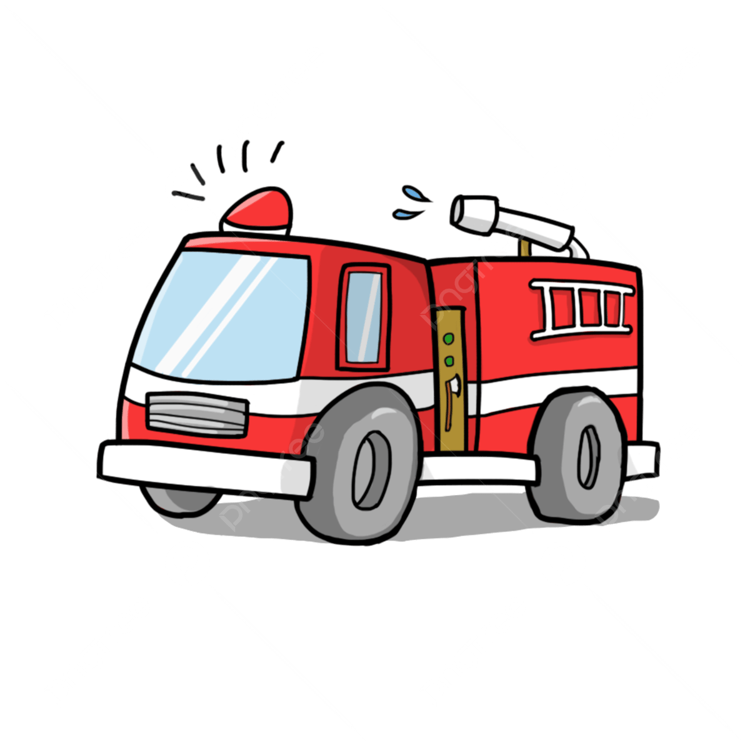







Campers will enjoy
artwork and crafts, Marshall Arts, a visit from the Fire Department for an afternoon of water – soaked fun! There will be loads of other games and outdoor fun!
Activities
We’re bringing the animals to you!

The Bramble Park Zoo trained staff will feature many of their cutest, friendliest, fuzziest, and scaliest animals for our campers to see up close and even touch.
Zoo Crew!
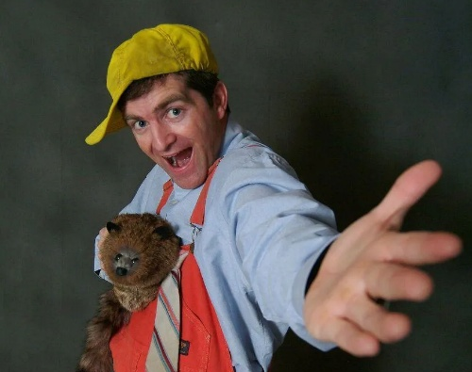

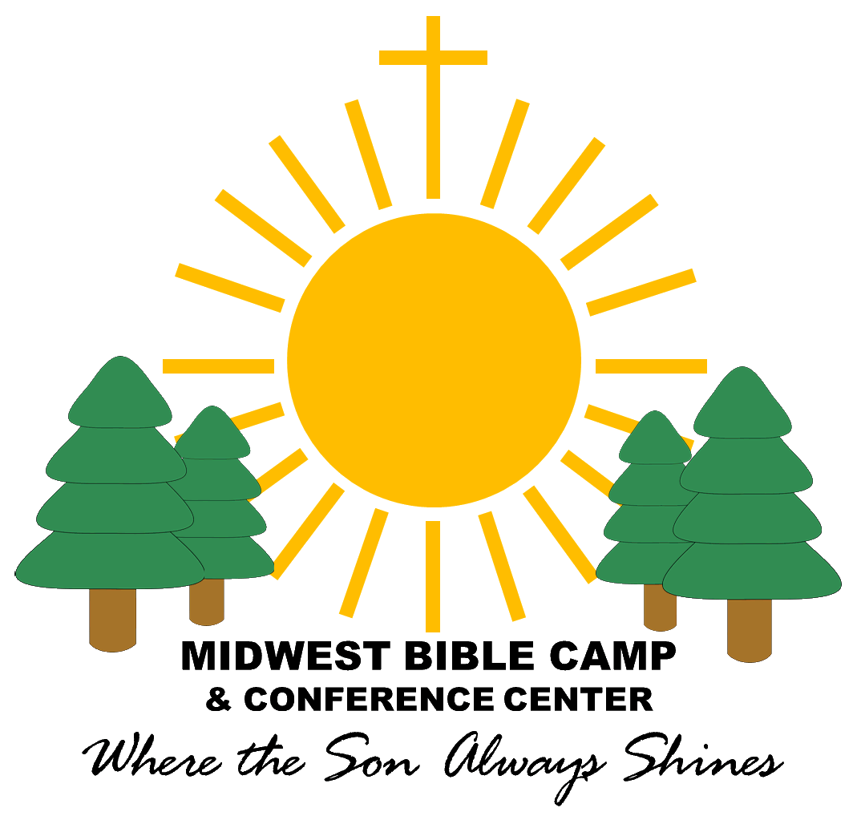
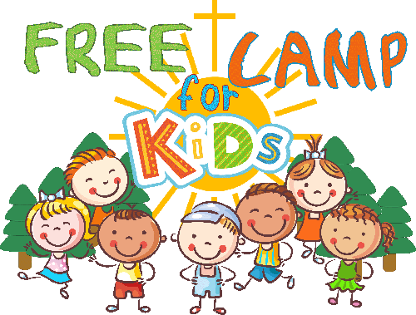
Featuring
Tom Toombs!
Ages 1st Grade – 17 years old
Day Camp or Overnight Stay
Each Camp closes with
FINAL DAY FAMILY FUN!
Thursday, June 17, 2027 &
Wednesday, June 23, 2027
Free Dinner for EVERYONE!
June 20-23, 2027
June 14-17, 2027
With the safety of our campers in mind, we utilize the training processes from the Safeguard from Abuse program. Each of our staff, including Camp Counselors must complete the training and adhere to strict guidelines. We require two adult counselors per cabin and 1/8 counselor/camper ratio. Birth gender requirements are adhered to in our dorms and restrooms.
Parents, grandparents, family & friends!

Join us on the closing day of camp
5-6PM: FREE COOKOUT SUPPER
6 PM: Closing Rally
After service, enjoy FREE ice cream and popcorn at the canteen. Join the fun!
Midwest Bible Camp
Our Purpose: The Midwest Bible Camp and Conference Center is to provide an interdenominational, Christian environment of biblical teaching and recreational activities which instill godly values and characters within children, youth, and families. Our facilities are available for family and group celebrations, special events, and outreaches which would serve as betterment for our community and surrounding area. Our programs exist to present the Good News about the wonderful grace of God; make available the means for individuals to experience such grace through acceptance of salvation that comes through faith in Jesus Christ; and provide a positive experience with others of like faith so that they may become mature disciples of Jesus.

1500 N Hwy 20, PO Box 545, Watertown, SD 57201
Ph: 605-886-3165 Email: info@midwestministries.org
Website: www.midwestministries.org
Facebook: Midwest Bible Camp and Conference Center
“Like” us on Facebook

Don’t Forget!
Final Day Family Fun!
FOR KIDS
Midwest Bible Camp
& Conference Center

